

Classroom Session: Using Query Parameters to Filter Description and Short Description, Displaying 15 Records in Get All Incidents
Learning Objective: The objective of this session is to learn how to use query parameters in ServiceNow API to filter incidents based on description and short_description, and to limit the results to 15 records using Postman.
Expected Completion Time:
- Best Case: 25 minutes
- Average Case: 35 minutes

ServiceNow API Credentials:
- Obtain Your ServiceNow Instance Credentials:
  - Instance URL
  - Username
  - Password

Using Query Parameters to Filter Incidents:
Step 1: Create a New Request
- Click on "New" and select "HTTP Request".
- Name your request appropriately, e.g., "Filter Incidents".
Step 2: Set Up the Request URL
- Set the request type to GET.
- Enter the ServiceNow API endpoint for retrieving incidents:
GET https://<your_instance>.service-now.com/api/now/table/incident
- Replace <your_instance> with your ServiceNow instance name.
Step 3: Set Query Parameters
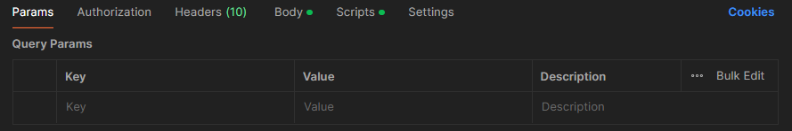
- Click on the "Params" tab.
- Add the following query parameters:
  - sysparm_query:
  - Key - description <your_description_value>
  - Key - short_description <your_short_description_value>
  - Key - sysparm_limit: value-15
Step 4: Authentication
- Go to the "Authorization" tab.
- Select "Basic Auth".
- Enter your ServiceNow Username and Password.
Step 5: Send the Request
- Click "Send".
- Observe the response in the lower pane. Ensure it contains the filtered list of incidents.
Step 6: Validate Response
- Verify the response contains up to 15 records and matches the filter criteria.
Step 7: Optional: Automate Validation Using Tests
- Go to the "Scripts" tab and add the following script to validate the response:

pm.test("Status code is 200", function () {
pm.response.to.have.status(200);
});

pm.test("Response contains 15 or fewer records", function () {
var jsonData = pm.response.json();
pm.expect(jsonData.result.length).to.be.at.most(15);
});

Expected Outcome:
Upon completion, you should be able to:
- Understand how to use query parameters in ServiceNow APIs.
- Filter incidents based on description and short_description.
- Limit the results to 15 records.
- Validate the response to ensure it meets the criteria and displays the expected number of records.

